Kate Walters
Children’s Literature
SLM 503.01

Literature Activities
Insects: Creepy Creatures? or Beautiful Beings?

Target Audience:

The target audience members are students who are in third grade in the Frederick County Public School system. The literature activity will take place during their science lesson of the day.

Program Theme:

The theme of this literature activity is insects and their worthwhile contributions to the Earth’s ecosystem. This theme is enforced through a picture book, a pre-assessment of insects, and a cross-curricular activity involving language arts (poetry) and environmental science.

Program Objectives:

By the end of this lesson, students will
- understand the definitions of apendage, arthropod, insect, crustacean, and arachnid.
- discuss insects and their relationship with humans.
- recognize the complexity of two-part poems through mimicking a recording and reading independently (in groups of two).

FCPS Indicators Met:

SC300.30.05.a: Explain ways that individuals and groups of organisms interact with each other and their envivornment.
SC300.30.05.b: Explain that changes in an organism’s habitat are sometimes beneficial and sometimes harmful.

Program Content/Materials:

- Pre-Assessment Hand-out: Clip-Art of Insects
- Appendage, Arachnid, Crustacean, Insect, and Arthropod Power Point
- Have You Seen Bugs? by Joanne Oppenheim
- Joyful Noise: Poems for Two Voices by Paul Fleischman
- Highlighted copies of poems
- CD-recording of Joyful Noise: Poems for Two Voices
- Paper Plates
- Pipe Cleaners
- Crayons
- Yarn
- Exit-Slips

Program Procedure:

Pre-Assessment (10 min.):
- Students, once filed into the media center and seated at the media center tables, will be handed a hand-out with various pictures of “bugs”. At the top of the hand-out will be four terms: “arachnids”, “arthropod”, “crustacean”, and “insect”. For each of the pictures, students need to write down whether they think each one is a crustacean, arachnid, insect, and arhtropod.
- Once students have taken some time with this, go over the answers, stressing that wrong answers are totally acceptable.
- Then, using the Power Point, give students the definition of each one (including the word appendage), ending with “arthropod”. They will write these definitions on the back of the hand-out.
Teacher-Directed (10 min.):
- Ask students to gather around and read them Joanne Oppenhiem’s Have You Seen Bugs? reinforcing the four terms learned through the pre-assessment activity.
Guided Practice (10 min.):
- Give a book talk on Joyful Noise: Poems for Two Voices
  - Winner of the John Newbery award
  - Poetry book; each poem has two voices
  - The relationship between this concept of reading two poems at once and singing a duet (“Heart and Soul”, “Baby, it’s cold outside”, “Frere Jacques”)
- Hand out copies of “Grasshoppers” and “Mayflies”.
- Explain the concept and the highlighting technique (yellow if someone is reading separate; green if both voices are reading at the same time). Highlighting the separate parts accommodates the needs of the visual learners.
- Students will read along as they listen to the CD recording of “Grasshoppers”.
- Media Center Specialist and Teacher will use pre-made masks of Mayflies to read the poem aloud, modeling how students should do it. All of these models (recording, reading along with recording, classroom teacher/Media Center Specialist duet) accomodates the needs of the auditory learners.
Independent Practice (15-20 min.):
- Assign students to groups of three based on suggestions from classroom teacher.
- Each group member has a role. The roles are as follows:
  - Role #1: Reader #1-reads the left side of the poem
  - Role #2: Reader #2-reads the right side of the poem
  - Rehearsal Director-is not required to read for the presentation, but must help group mates practice
- Each group member must make a mask.
- Groups will be given their poems. Once they have their poems, they will have 10 minutes to create their masks and 5 minutes to go through their poems 2-3 times
Presentations (10-15 minutes):
- Groups will then present their poems (while wearing their masks) for the class. Media Center specialist and classroom teacher will be available to help with word pronunciation and/or keeping time.
Assessments:
- Students will be handed an exit slip to complete before they leave the media center with their teacher. The exit slip will ask the following questions:
  - What is one thing you learned about insects?
  - What insect was your group required to learn and read about?
  - What is one thing you liked about one of the presentations?
- Media Center Specialist will collect slips for assessment of learning and for improvement of literature activity.

Extension Resources
Annotated Bibliography

Because this literature activity does align with the third grade science curriculum in FCPS, classroom teachers may want to reference some of the following materials as extension activities or resources to use in the general classroom.

“Growing up Creepie.” Discovery Kids. http://kids.discovery.com/fansites/creepie/ (accessed April 10, 2008).

This show is on Discovery Kids, however the website provides a lot of neat background about the show and its characters. Creepie, a human orphan is raised by a family of insects in an abandoned mansion. Her insect family, however, wants her to grow up to be a normal human being and makes her go to school. There she attempts to acclimate while maintaining her family identity. This fansite provides the viewer with, not only an overview of the show, but also some cool bug facts and video.

“Insects.” BrainPop. www.brainpop.com.

Although this fabulous site needs to be purchased either through a school system, an individual school, or for personal use, it is valuable and helpful in all areas of elementary education. The Insects page provides a 4 minute video on insects, a quiz, some commonly asked questions, and a timeline. It is an excellent source to use during an insect literature activity, before a literature activity, or as a follow-up back in the students’ classroom.

“Insects Tour.” The Magic School Bus. http://www.scholastic.com/magicschoolbus
/tour/tour.htm?insects (accessed April 10, 2008).
On this site, students may play games (taking pictures of insects, creating their own insects, etc.), take a quiz, or watch a video clip from the Magic School Bus on spiders. Not as easy to maneuver as the BrainPop site, but it does still provide a lot of excellent information and is connectable to students (because of their previous exposure to the Magic School Bus program).

Kramer, Stephen. Hidden Worlds: Looking Through a Scientist’s Microscope. Photography by Dennis Kunkel. Boston: Houghton Mifflin Company, 2001.

What makes this book such an excellent supporting text is its photography. Almost every page has at least one microscope photograph of an insect, up-close, colorful, and (sometimes) gruesome. The excellent aspect of these photographs is how detailed they are. Students will be able to identify body parts of insects because the miscroscope photographs are so clear and close that every detail is recognizable.

Simon, Seymour. Animals Nobody Loves. New York: SeaStar Books, 2001.

Eech! It’s a commonly known fact that there are some animals in the world that noone likes. They’re ugly, they’re dangerous, they’re annoying. But if a person were to stop and think about these animals (grizzly bears, rats, man-of-wars), he might realize that these animals, despite how distasteful they are, live to survive through any means possible. Seymour Simon realizes this and through his simple descriptions and clear, entrancing photographs, the reader learns about these hated animals and why they are Earth’s children too. This book is an excellent extension to this literary activity because it aligns with the actual unit on populations and the ways animals interact with their environment. The fact that its about ugly and dangerous animals makes it that much more fun!

Professional Resources
Annotated Bibliography

I referenced the following professional resources as I prepared for the creation and presentation of this elementary school literature activity assignment.

Beavin, Kristi. “Audio Book Reviews: Paul Fleischman Poems for Two Voices.” Horn Book Magazine 77, no. 3 (May/June 2001).

Though short, this review of the newly-released audio book that accompanies Paul Fleischman’s poetry book (Joyful Noise: Poems for Two Voices) is helpful. The review gave me two valuable pieces of information. First, I now know that an audio book is available and can be used as a pre-activity before the students are asked to read the poems on their own (students could even read in conjunction with the recording). The second important piece of information tells me that there were previous recordings, but according to this review, the 2001 recording is the most engaging as it “lifts the words off the printed page and sets them free in the imagination.”

Brown, Sherri. “What's Bugging You?: A 5E Learning Cycle Introduces Insect Classification.” Science and Children 43, no. 7 (Apr/May 2006).

This article that appeared in a spring issue of the popular education journal Science and Children provided me with information about students’ understanding of insects. It recommended I look up various definitions of arthropod, arachnid, insect, and bug and then use this information as a pre-assessment for an activity surrounding insects and their role in the ecosystem. It also provides some excellent extension activities for a 3-5 grade classroom.

“Essential Curriculum-Science Grade 3.” FCPSTeach. http://www.fcpsteach.org/docs/Grade%203%20EC.doc (accessed April 10, 2008).

I have chosen to cater my literature activity about insects to the Essential Curriculum for third grade in Frederick County. I chose to do this because in third grade, students (underneath the Populations Unit), study ecology and the way groups of organisms interact with each other and their environment. Insects are everywhere and a child will be able to connect to this lesson and the unit because of their early exposure to insects.

Hevel, Gary. “Science 101: How Do Insects Help the Environment?” Science and Children 42, no. 5 (Feb 2005).

This article, though simple, coincides well with the environmental studies unit on which I based my literature activity. What was most intriguing was that Hevel connects insects to our cultural world and how, throughout history, insects have been revered in some cultures. This coincides beautifully with the connection between insects and poetry that the students will encounter during the literature activity.

Name: ___________________________

Date: ___________________________

What do you know about Bugs??

Using each word in the word bank below only once, match the correct word with the picture.

Word Bank

Appendage Arachnid

Insect Crustacean

1. 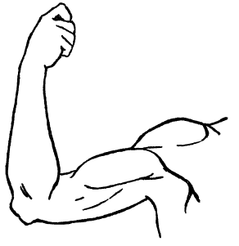 ________________________________

2. 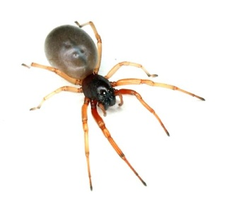 ________________________________

3. ________________________________

4. 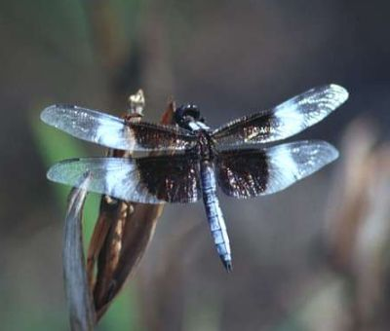 _________________________________

Using the information on the Power Point presentation, write down the definition for each word in each box and then draw a picture of what the word is.

Appendage: | Arthropod:
Insect: | Arachnid:
Crustacean:

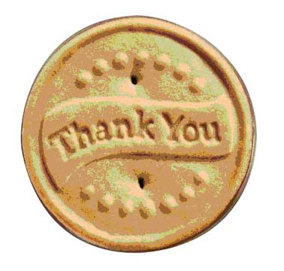
Name: ___________________________
Media Center Exit Slip
Please answer the questions in complete sentences.

1. What is one thing you learned about insects?

2. What insect was your group required to learn and read about?

3. What is one thing you liked about one of the poem presentations?

Name: ___________________________
Media Center Exit Slip
Please answer the questions in complete sentences.

1. What is one thing you learned about insects?

2. What insect was your group required to learn and read about?

3. What is one thing you liked about one of the poem presentations?

