A Letter to My Readers

Dear Friends,

This list is for you,
As you sit and you think;

“Do I want something new?
Or some food or some drink?

“Perhaps something to see,
a baseball game or a show?

“No! Oh woe is me!
I simply don’t know!”

Well I do know, dear child.
I don’t mean to be rude,

What you want can be wild
If you’re in the right mood.

You won’t find it on TV,
so don’t even look.

What I think you will see,
Is that you want a book!

A book with colors and shapes,
Or a book with just words.

A book where you can escape
Or that might be absurd.

Perhaps a book about sports
or a book with vampires.

Say you need to write a report
Without being a liar…

Well pick up these books!
And let your mind fly free,

Let yourself become hooked.
I think you’ll agree,

That to read is a gift
Books teach and entertain.

So, take a look at this list,
Read these books again and again!

Your Friend and Fellow Book Fiend,
Kate Walters

Table of Contents
Annotated Children’s Books

Introduction Letter to Children i

Acknowledgements iii

Picture Book Annotations 1

Easy Reader Literature Annotations 9

Transitional Literature Annotations 12

Intermediate Novels Annotations 16

Multicultural Literature Annotations 22

Fairy and Folk Tales Annotations 24

Science and Math Tradebooks Annotations 28

Biography Annotations 32

History Annotations 35

Children’s Poetry Annotations 37

Graphic Novels Annotations 40

Index by Authors’ Last Names 42

Awards Descriptions 50

Asch, Frank. Mr. Maxwell’s Mouse. Illustrated by Devin Asch. Ontario: Kids Can Press Inc., 2004. Grades 1-3.

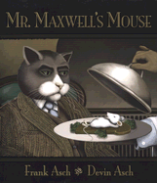 | Beware of a mouse with manners! Mr. Maxwell, a well-bred cat wearing a smart business suit, has been promoted and decides to celebrate. During his daily lunch at the Paw and Claw, he does not order his usual baked mouse. Instead, he asks for a raw mouse, excited to kill his own lunch for a change. The mouse arrives, and he, using extremely genteel manners, begins to chat with Mr. Maxwell. The chatty mouse has a plan, though, and Mr. Maxwell soon realizes he should have ordered his “usual” baked, already-dead mouse.

Cronin, Doreen. Click, Clack, Moo: Cows That Type. Illustrated by Betsy Lewin. New York: Simon and Schuster Books for Young Readers, 2000. Grades PreK-2.

If a cow could type, what would he say? Find out as Farmer Brown’s cows cause him much stress. By typing out requests and messages to him from the old typewriter in the barn, Farmer Brown’s cows, and eventually chickens, make demands that he refuses to meet. The result is a hilarious typed argument between the Farmer and his barnyard animals. Who wins? The victory could go to either side. One thing is definite, however. The Farmer must not underestimate his ducks. They have typed demands of their own. | 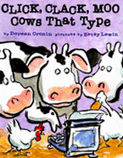

Falconer, Ian. Olivia. New York, Atheneum Books for Young Readers, 2000. Grades PreK-2.

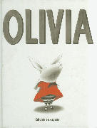 | An enchanting story about a wayward young piglet who wears her mother out. Olivia adores getting dressed, moving the cat when he needs moving, making sand skyscrapers, and visiting museums. She also dances whenever and however she can, whether it is when she should be napping or in her imagination as she stares at her favorite picture in the museum. Though Olivia wears out her mother, especially when she paints all over the wall or insists that they read five books at night, Olivia’s mother still loves her anyway.

Fierstein, Harvey. The Sissy Duckling. Illustrated by Henry Cole. New York: Simon and Schuster Books for Young Readers, 2002. Grades 2-5.

Elmer can’t help it. He does not like to box with the other ducks, he dislikes playing football, and he can’t throw, catch, or hit a baseball. Instead, he loves baking, making sandcastles, and putting on puppet shows. But, when all of the other boy ducks call him a “sissy” and his own father claims that Elmer “is no son of mine,”Elmer runs away before the ducks fly south for winter. But an unfortunate accident and a long, hard winter help change the ducks’ perceptions of Elmer and his unusual talents. | 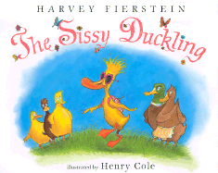

Gerstein, Mordicai. The Man Who Walked Between the Towers. New York: Scholastic Inc., 2003. Grades 2-4.

A quarter of a mile into the sky, Phillipe Petit is walking on a wire. The wire is pulled between two familiar New York City buildings: the Twin Towers. Phillipe is good at walking, dancing, laying, and balancing on tight ropes. But he feels unchallenged and decides that he must walk between the Twin Towers. He climbs to the top, pulls a cable tight between the two buildings, and walks as though nothing can stop him. People from below stare and police officers call to him as, for over an hour, Phillipe fulfills his dream.

Hall, Donald. Ox-Cart Man. Illustrated by Barbara Cooney. New York: The Viking Press, 1979. Grades 2-4.

A story of a family who dwells in the country on a farm. They live in a simpler time, where people travel in carts, grow their own food, and create their everyday household items. The father, in October (before the season becomes too cold), travels for ten days to reach Portsmouth and sells his family’s crops, wares, cart, and ox. While in the city he buys gifts for his family and then travels home. During the following winter, spring, and summer, the family creates and harvests for the father’s next Autumn trip to the bustling city. | 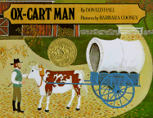

Henkes, Kevin. Kitten’s First Full Moon. ____________: Greenwillow Books, 2004. Grades PreK-1.

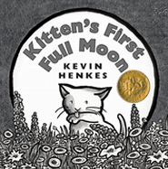 | Poor Kitten! It’s nighttime and she’s hungry. Up in the sky, she spies a big bowl of milk just waiting for her to come and drink it. The only problem is, no matter how Kitten tries to reach the milk, she never seems to get close enough! Follow the kitten’s frustrating journey from lighting bugs, to trees, to a pond, and back home again as she tries to reach the bright white, oh-so-large bowl of milk in the night sky.

Justern, Norton. The Hello, Goodbye Window. Illustrated by Chris Raschka. ____??: Hyperion Books for Children, 2003. Grades K-3.

As she listens to Poppy play his harmonica, as she works with Nanna in the garden, and as she gazes at the stars her Nanna knows by heart, the young main character of Norton’s story emphasizes how much her visits to her grandparent’s house mean to her and to them. As she gazes through the large kitchen window, the main character’s imagination creates anything she wishes to see: Tyrannosaurus Rex, the Pizza Delivery Guy, the Queen of England, and herself, loving the simple joy of her time with Nanna and Poppy. | 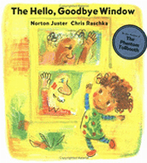

McLeod, Bob. Superhero ABC. New York: HarperCollins Publishers, 2006. Grades 1-5.

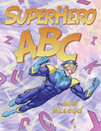 | Learning your ABCs was never this fun! Soar through the air, water, and Zero Zone with these superheros that have very odd superpowers and that all represent a different letter of the alphabet: Danger Man, Goo Girl, Odor Officer, Water-Woman and many more. McLeod uses tongue twisters and rhyme to help the reader learn his or her ABCs while providing brilliant cartoon-like illustrations that use bright colors and hilarious word bubbles to simulate comic-strip dialogue.

McPhail, David. Edward and the Pirates. Boston: Little, Brown and Company, 1997. Grades K-2.

Edward, once he begins reading, cannot stop. And it is adventure stories, the stories of Robin Hood, pirates, or Joan of Arc, that truly spark his imagination. Imagine you are on a sledding dog journey or riding on a horse holding a shield for protection. Imagine, as you read, a Tyrannosaurus Rex looks into your window. But, more than anything, imagine as Edward does, a band of pirates sneak into your room and demand you help them find treasure! | 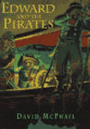

Morris, Carla. The Boy Who Was Raised by Librarians. Illustrated by Brad Sneed. Atlanta: Peachtree Publishers, 2007. Grades K-2.

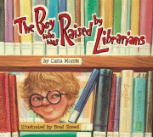 | The perfect place for a child who needs to know everything is the library. The perfect friends for a child who needs to learn all about the world are librarians. Why? Librarians love helping. Melvin, a child who needs to know everything, spends everyday in the library. Throughout elementary, middle, and high school, Melvin learns all he can about bugs, eggplants, baseball cards, and so much more from Marge, Betty, and Leeona, the librarians. So where should Melvin work when he grows up? Melvin knows: the library.

Murray, Marjorie Dennis. Don’t Wake Up the Bear! Illustrated by Patricia Wittmann. New York: Marshall Cavendish, 2003. Grades PreK-1.

In this delightful story, an almost-frozen hare, badger, fox, squirrel, and mouse find warmth curled up against a sleeping bear in his cave. There is snow on the ground, but inside, the bear’s cave is clean, dry, and warm. The animals, afraid to wake the bear but too cold to remain in the snow, huddle together against the warm bear’s fur. Unfortunately for the animals, the little mouse has the sniffles and her noises may prevent them from enjoying the warmth in the cave for much longer. | 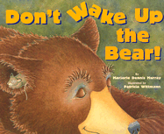

Musch, Robert. Love You Forever. Illustrated by Sheila McGraw. Ontario: Firefly books, 1986. Grades PreK-1.

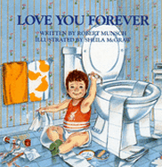 | Sometimes loving a son is difficult, especially for his mother. His antics as a child, his attitude as a preteen, his craziness as a teenager, and his departure from home as an adult all make his mother crazy. And yet, as he goes through life, his mother continues to show her love for him through her nighttime song that ends, “As long as I’m living my baby you’ll be.” As her son grows up, his mother grows old and he learns to treat his mother (and his new daughter) with the same love that she gave him through his life.

O’Malley, Kevin. Once Upon a Cool Motorcycle Dude. Illustrated by Scott Goto, Carol Heyer, and Kevin O’Malley. New York: Walker and Company, 2005.

Fairytales are girly stuff. Princesses? Magical horses? Spinning thread into gold? What dude wants to read about that? Wait! What if a princess was in trouble and a cool motorcycle dude rode to her rescue? Fairytales can be totally cool if girls and boys work together to tell the story. All they need to do is combine ideas, work together through the plot, and…and…and, well, they don’t really need to work together. As long as they both tell their fairytale like they do in this story, everyone can enjoy the action (and romance…sigh). | 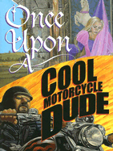

Priceman, Marjorie. Hot Air: The (Mostly) True Story of the First Hot-Air Balloon Ride. New York: Atheneum Books for Young Readers, 2005. Grades 2-4.

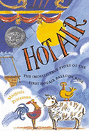 | It is 1783 in France and a large, curious crowd has gathered at Versailles, the royal palace. Joseph and Etienne Montgolfier have created the first hot-air balloon. The crowd has gathered to witness the first flight. The passengers? A duck, a sheep, and a rooster?! The larger-than-life drawings follow the thrilling, (sometimes) dangerous 12-minute journey of the first hot-air balloon passengers. At the end, the author provides a short history of the Montgolfier’s balloon project from the idea to the first flight.

Sierra, Judy. Mind your Manners, B. B. Wolf. Illustrated by Jotto Seibold. New York: Random House Children’s Books, 2007. Grades K-2.

Everyone has always mistrusted Big Bad Wolf. He chased Little Red Riding Hood, he blew down the pigs’ houses (at least two), and he terrorized sheep. However, he still gets an invitation from Miss Wonderly to attend a fancy tea at the library with other fairytale characters. His best friend, the crocodile, quizzes him on manners so that B. B. Wolf doesn’t offend anyone by burping, slurping, or biting. In the end, B. B. Wolf shows everyone, through his good manners and conversation, that as an evil fairytale character, he is misunderstood. | 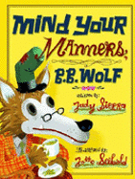

Steig, William. Sylvester and the Magic Pebble. New York: Simon and Schuster Books for Young Readers, 1969. Grades K-2.

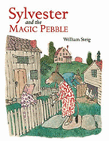 | A story about the danger of wishing too much and too often. Sylvester, like any young donkey, has a fine collection. He collects interesting pebbles. One day, he finds an especially unusual pebble that he discovers is magic. Unfortunately a magic pebble is not the ideal item to have when Sylvester comes in contact with a lion. He loses his family and freedom all in a second. What will become of Sylvester and how will the magic pebble make everything right again?

Stryer, Andrea Stenn. Kami and the Yaks. Illustrated by Bert Dodson. California: Bay Otter Press, 2007. Grades 3-5.

Kami is young, deaf, and alone. His family’s yaks are wandering lost in a storm atop the Himalayan mountains. Kami knows that without the yaks, his family will not be able to guide the mountain climbers to make a living. Despite his fear, Kami looks everywhere, blowing his whistle, calling for Curly Horn and the other yaks. Yet when he discovers where they are, his deafness and inability to speak make it difficult to convince his father and brother that he knows where to find the yaks and that they must rescue the animals soon! | 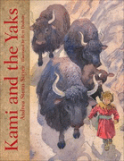

Waber, Bernard. Ira Sleeps Over. Boston: Houghton Mifflin Company, 1972. Grades K-3.

A story about teddy bears, and two boys stuck between childhood and growing up. Ira is sleeping over at Reggie’s house. His mocking older sister asks him if he plans on taking Tah Tah, his teddy bear. Ira, torn between needing Tah Tah at bedtime and embarassment that he actually has a teddy bear, finally decides to leave Tah Tah at home. During the night, right before he and Reggie fall asleep, Reggie pulls out Foo Foo, his teddy bear and Ira realizes how alike he and Reggie actually are.

Watt, Melanie. Scaredy Squirrel. Ontario: Kids Can Press Inc., 2006. Grades K-2.

What do you call a squirrel who never leaves his tree because he is afraid of tarantulas, poison ivy, green Martians, germs, killer bees, and sharks? Scaredy Squirrel. He spends every day in his tree eating nuts and watching his view. Although he has a number of plans in place in case of an emergency (poison ivy, germs, and other dangerous beings), a killer bee still makes its way into his tree and he must modify his escape plans in this hilarious children’s book about being too prepared for hazardous situations. | 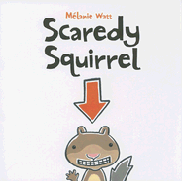

Wiesner, David. Flotsam. New York: Clarion Books, 2006. Grades K-3.

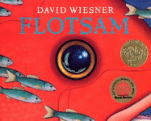 | Not just a beach story where a boy plays in the water and sand. In Flotsam, an old, barnacled camara washes up on shore and a boy is drawn to the old camara and eventually is in awe of what its photographs reveal. After developing the pictures and replacing the film from the camara, the boy discovers an underwater world he had never dreamed existed. Share the boy’s joy through a thorough examination of the photographs that open his and many other children’s eyes to the mysteriousness of the ocean.

Willems, Mo. The Pigeon Finds a Hot Dog! New York: Scholastic Inc., 2004. Grades PreK-3.

The pigeon has found a hotdog. “Scooty, scoot, scoot!” In comes a curious duckling. The nosy duckling keeps the hungry pigeon from enjoying his hotdog in peace. Instead, the pigeon must answer many of the duckling’s questions because the duckling says he has never had a hotdog. What does the hotdog taste like? Does it taste like chicken? So, it doesn’t taste like chicken, then? After much pestering on the duckling’s part, the two birds reach an agreement and the book ends with peace, quiet, and a delicious hotdog. | 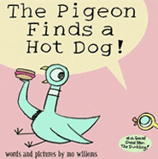

Williams, Vera B. A Chair for My Mother. New York: Greenwillow Books, 1982. Grades 1-3.

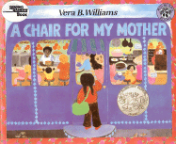 | A story about rebuilding after a tragedy, A Chair for My Mother follows the journey a daughter, mother, and grandmother make to buy a large, comfortable armchair to make their home complete again. For an entire year, the three of them save coins to buy the chair that will replace the one they lost in a devestating house fire. The tips the mother makes at a diner and the leftover coins the grandmother has from grocery shopping all go into a jar until there is enough to buy the perfect armchair for their home.

Yolen, Jane. Piggins. Illustrated by Jane Dyer. San Diego: Harcourt Brace Jovanovich, 1987. Grades K-3.

It’s a mystery only the butler can solve! Piggins, the fussy but proper butler for the Reynards, is called on to solve a mysterious theft. The Reynards who are wealthy, fancy foxes throw a dinner party for their friends. During the party, the lights go off, the guests hear a tinkling noise and a scramble of feet, many objects fall to the floor, and someone screams. Piggins must save the day first by turning on the lights and then by figuring out which of the guests has stolen Mrs. Reynard’s expensive but cursed diamond necklace. | 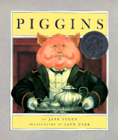

Berenstain, Stan and Jan Berenstain. The Berenstain Bears: The Bear Detectives. New York: Random House Children’s Books, 2002. Grades 1-2.

Farmer Ben’s prize pumpkin has been stolen from the fair and he is frantic! Luckily, the Berenstain bear cubs are ready for action. With their trusty detective kit and Detective Book, these four cubs begin the search. Unfortunately, Papa Bear and his old dog Snuff are at the fair too. Although he thinks he can help, Papa Bear seems to make even more trouble for the cubs. Will the bear cubs find the pumpkin? Will Snuff lead them in the wrong direction? Will Papa Bear let the real detectives work? Read and find out!

Brisson, Pat. Little Sister, Big Sister. Illustrated by Diana Cain Bluthenthal. New York: Henry Holt and Company, 1999. Grades 1-2.

When your big sister is in the pool, playing a game, or baking special cookies, what else is a little sister to do but join in? When your little sister is eager to play, eating a candy bar, or scared of thunder, what else is a big sister to do but take advantage of the situation? Join Hester and Edna as they show us what it means to share your family with a sister. Their adventures are touching and funny and end with a special story about sharing and spending special sister time together. | 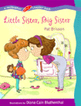

Brandenberg, Aliki. Fossils Tell of Long Ago. New York: HarperCollins Publishers, 1990. Grades 1-3.

In this enlightening book about fossils, Brandenberg helps the reader understand not only how fossils are formed, but what animals, insects, and plants have been discovered by scientists through the study of fossils. What makes the book so appealing is that the information is given to the reader, not through boring, typical informative reading, but through word bubbles from children just like the reader. Once finished with this book, anyone will be excited to go searching for fossils right in his or her backyard!

Kvasnosky, Laura McGee. Zelda and Ivy: The Runaways. Cambridge: Candlewick Press, 2006. Grades 1-2.

Cucumber sandwiches are not good. At least they aren’t good according to Zelda and Ivy, the young, playful foxes who decide to run away to avoid the sandwiches they hate. Not only do Zelda and Ivy run away to their backyard to play cards and write stories, one day they make a time capsule for young foxes of the future. And yet, another day, Ivy concots a magic potion, called creative juice, to help Zelda finish a poem. Zelda and Ivy’s playful stories show us that little fox sisters can have just as much fun as human siblings. | 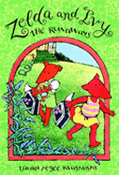

Parish, Peggy. Come Back, Amelia Bedelia. Illustrated by Wallace Tripp. New York: HarperCollins Publishers Inc., 1995. Grades 1-2.

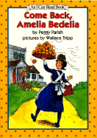 | Amelia Bedelia takes everything literally. If someone tells her to do something, she will do exactly that! Heat up a can of soup? The can goes directly into the water! Take cereal with coffee? The coffee mug is filled with cereal and coffee. It’s too bad because her boss, Mrs. Rogers fires her and Amelia Bedelia is forced to look for another job. Yet, everybody else also gets mad with Amelia Bedelia when she does exactly what they ask her also. However, Amelia Bedelia sure can bake, and her chocolate cream puffs might just save the day!

Ross, Dev. The Birthday Ban in Munchkin Land. Illustrated by David Hohn. San Francisco: Treasure Bay, 1999. Grades 1-2.

When the Wicked Witch of the East blew in on a tornado, noone in Munchkin Land could have anticipated how evil she would be to the Munchkins. Yet, she is so evil that she decides to ban birthdays! Twins Meezie and Tweeze, who were just about to celebrate their birthday, decide that it is time for the witch to go. With the help of Glinda, the good witch, a wise old tree, and Young Windbag (who has a knack for creating tornados), the twins set out to get rid of the evil witch and get their birthday back!  (Note: This book is a “We Both Read” book, meant to be read by both an adult and a beginning reader.) | 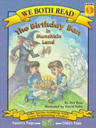

Rylant, Cynthia. Henry and Mudge: The First Book. Illustrated by Sucie Stevenson. New York: Simon and Schuster Books for Young Readers, 1987. Grades 1-2.

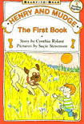 | Henry’s parents look around their house and neighborhood and realize why Henry is so lonely: no brothers, no sisters, no friends who live nearby. So, they venture out and buy him Mudge. Mudge is a small, furry puppy, until he grows and grows and grows until he much larger than Henry. Read the first of many delightful books about Henry and his pal Mudge as they walk together to school, eat breakfast and supper at the same time, and cuddle up together at night. Henry and Mudge truly are the best of friends.

Silverman, Erica. Cowgirl Kate and Cocoa. Illustrated by Betsy Lewin. Orlando: Harcourt Inc., 2005. Grades 1-2.

You’ve never met a horse this needy before! Cocoa is always hungry, he is often tired, he needs his straw fluffed, he needs his water filled. Kate, his owner, sometimes pretends to get tired of all Cocoa’s wants and needs, yet the reader can tell that she loves Cocoa more than anything. And the same is true for Cocoa. When Kate climbs a tree, he worries. When Kate cannot fall asleep, Cocoa sings her a lullaby. And when Kate just needs a friend on the ranch, Cocoa is always there. | 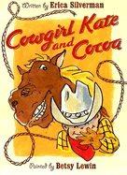

Willems, Mo. I am Invited to a Party! New York: Hyperion Books for Children, 2007. Grades K-2.

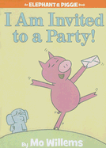 | Gerald the Elephant knows parties. So when his friend Piggie is invited to a party, he agrees to go to the party with Piggie and he also agrees to help Piggie dress to impress. Is it a fancy party? Is it a costume party? Is it a pool party? Neither Gerald nor Piggie know. But Gerald has a fullproof plan to help Piggie prepare to party no matter the occasion or theme. The expressions and antics of Gerald and Piggie are hilarious when accompanied by the frantic word bubbles of Piggie and the clever word bubbles of Gerald.

Cameron, Ann. The Stories Julian Tells. Illustrated by Ann Strugnell. New York: Pantheon Books, 1981. Grades 2-3.

With Ann Cameron’s lyrical stories of a child’s imagination and Ann Strugnell’s magnificent ink drawings, any reader will be pulled into the world of Julian and his younger brother Huey. The stories in this transitional book remind us of how extensive a child’s imagination can be. Perhaps a bowl of pudding does taste like a raft of lemons. Perhaps leaves off of a fig tree do help a young boy grow taller. Perhaps invisible cats do prowl around a graden, helping the plants grow. Anything is possible in Julian’s head.

____________. The Stories Huey Tells. Illustrated by Roberta Smith. New York: Alfred A. Knopf, Inc., 1995. Grades 2-3.

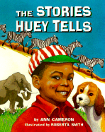 | Continuing the story of Julian and Huey’s sometimes zany family, Ann Cameron returns with brilliant stories of Huey and the ongoing battle he has with being Julian’s younger brother. Step inside Huey’s head as we see his imagination at work. From his scary nightmares of falling to the tricks he plays on Julian, we see how important family acceptance and understanding is to a younger brother. We also realize how difficult it can be to eat mushrooms (which might have been elf houses), and trout when the trout’s eye is staring right up at you!

Edwards, Michelle. Stinky Stern Forever. Orlando: Harcourt Inc., 2005. Grades 2-5.

What happens when a group of elementary-level students is forced to think openly and honestly about death? As students Pa Lia, Calliope, Howie, Oliver, Bridgett, Madison, Will, Molly, and their classmates confront the subject of death by mourning one of their own, we learn that remembering someone after life , both the good and the bad, can have a soothing and strengthening effect. | 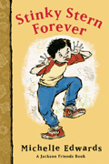

Greenwald, Sheila. Rosy Cole’s Worst Ever, Best Yet Tour of New York City. New York: Farrar, Straus and Giroux, 2003. Grades 2-3.

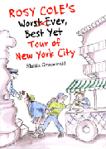 | In New York City, there are so many sites to see! Rosy Cole is lucky because her small-town cousin is visiting and she gets to show off the whole city to him! But, Rosy does not consider what might go wrong if she suddenly comes down with a cold, if the day is rainy, if her best friend Hermione butts in too often, or if her cousin Duncan is afraid of crowds and heights. As Rosy’s tour goes from bad to worse, she begins to realize what it is that truly makes New York City a special place to visit and live (hint: it’s not big buildings).

Hest, Amy. Love You, Soldier. Illustrated by Sonja Lamut. Cambridge: Candlewick Press, 2000. Grades 2-4.

Life is hard for a young girl during wartime. Life is especially difficult when the war takes a girl’s father to fight in a country far away. And yet, life continues on for Katie and her mother as they work hard, living in a small apartment in New York City. Katie helps their friend Louise walk to the hospital to deliver a baby in a snowstorm. Katie and new baby Rosie become friends, almost like sisters. Even when tragedy hits Katie and her mother, they continue to love one another and learn how to repair their lives after their loss. | 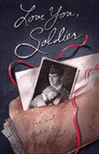

Look, Leonore. Ruby Lu, Brave and True. Illustrated by Anne Wilsdorf. New York: Antheneum Books for Young Readers, 2004. Grades 2-3.

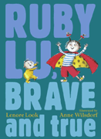 | A story about a smart energetic eight-year-old Chinese-American girl who performs magic tricks, attempts to drive a car, and loves to go to Chinese school. Meet Ruby Lu, a girl who demonstrates how much she likes life, from riding the bus to her grandparent’s house to opening and closing her brand new wallet. Hang out in this transitional book with Ruby as she makes new friends and learns how to be a big sister to baby brother Oscar (later to become her assistant in her magic show).

McDonald, Megan. Judy Moody. Illustrated by Peter Reynolds. Cambridge, Massachusetts: Candlewick Press, 2000. Grades 2-3.

There is a reason she is called Judy Moody! Constantly battling bad moods, Judy grumbles as she gets up in the morning, snaps at her friends, gives the wrong answers in class, and picks on her little brother. However, a lot can change Judy from grumpy and whiny to happy and cheerful again. Join her, Stink (her short younger brother), and Rocky, her laid-back best friend, as Judy realizes how terrific her life can be and how special she is when she finally finishes her “Me Collage”! | 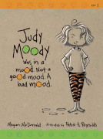

_______________. Stink the Incredible Shrinking Kid. Illustrated by Peter Reynolds. Cambridge, Massachusetts: Candlewick Press, 2005. Grades 1-3.

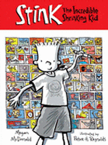 | Life is tough being one of the shortest students in second grade. But, life is made even more difficult for James “Stink” Moody by his taller older sister, Judy, who is constantly teasing him about his height. Luckily, throughout this transitional reader, Stink makes himself feel better by taking care of the class pet newt and studying his favorite president, President James Madison. Stink spends hours working on his president project because of his connection to James Madison. Many people do not know that…James Madison was the shortest American President!

Park, Barbara. Junie B. Jones and her Big, Fat Mouth. Illustrated by Denise Brunkus. New York: Random House, Inc., 1993. Grades 2-3.

Life is hard for Junie B. Jones. She is constantly telling lies because of her big, fat mouth. And when she swears on the bus that, for job day, she is going dress up as a person who saves people, paints, and carries a big keychain, nobody believes her. And then, when she shows up in school dressed as someone who saves people, paints, and carries a big keychain, everyone in class laughs at her. Life is hard fo June B. Jones, but sometimes her big, fat mouth doesn’t just get her in trouble; it gets her out of trouble. | 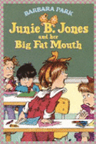

Pennypacker, Sara. Clementine. Illustrated by Marla Frazee. New York: Hyperion Books for Children, 2006. Grades 2-3.

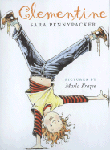 | Whether she is cutting off all of her hair or solving the pigeon problem for her father, Clementine is always paying attention to something. Too bad for her, usually everyone is paying attention to something different. Clementine marches to the beat of her own drum. She can’t help that sharp things make her nervous or that homework just keeps disappearing under her bed. She just wants to help. And through her unique and childlike perspective, Clementine does help everyone: her parents, her best friend, even Principal Rice.

Roberts, Ken. The Thumb in the Box. Illustrated by Leanne Franson. Toronto: Douglas and McIntyre, 2001. Grades 2-3.

New Auckland is a small, fishing town on the western coast of Canada. Leon, the boy who always smiles, and his father, the principal of the six-room school, live there among a variety of odd characters including Susan, the gullible girl genius, Muriel, the African lion, and Annie Pritchard, the seventy-seven-year-old world famous artist. Over the course of the story, the townspeople, who have always lived without a road or vehicles, must decide on whether or not they should accept the Canadian Government’s gift of a fire engine.

Avi. The True Confessions of Charlotte Doyle. New York: Orchard Books, 1990. Grades 4-6.

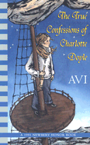 | The year is 1832 and Charlotte Doyle’s father has required her to stay behind in England to complete her school term. She is to follow her family a few months later aboard a ship owned by her father. Although Charlotte had planned on traveling with other families, quite a few problems arise at the last minute leaving Charlotte to travel across the Atlantic Ocean with only dirty, crude sailors, and an evil, harsh captain as her companions. The voyage is an adventure for Charlotte as she learns to stick up for herself and solve her problems using courage she did not know that she had.

Birney, Betty G. The World According to Humphrey. New York: G. P. Putnam’s Sons, 2004.

Humphrey the hamster belongs to Room 26. In Room 26, Golden Miranda (real name: Miranda Golden) and Speak-Up-Sayah (real name: Sayah Nasiri) take good care of him, along with the rest of the students. Too bad Mrs. Brisbane, the strange old teacher keeps calling him a rat! Humphrey doesn’t mind though. Instead, he works his hamster magic by helping students, parents, and even the principal solve some very perplexing problems. Perhaps he may even help Mrs. Brisbane too, if she would just let him get close!

Butler, Dori Hillestad. Trading Places with Tank Talbot. Morton Grove, Illinois: Albert Whitman and Company, 2003.

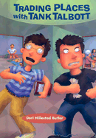 | Imagine a bully broke your best friend’s nose. Imagine your sister tortures all of the time. Imagine that, no matter how hard you try, you just cannot swim; putting your nose underwater produces instant panic. Imagine all of these these problems rolled up in one and you have Jason Pfeiffer, a dorky, movie script-writing 11 year old who is forced to take swimming lessons. Forced, that is, until he strikes a deal with Tank, the biggest bully around who is being forced to take dance lessons. Suddenly, the world doesn’t seem too bad to Jason. Pretty good, that is, until his parents catch on!

DiCamillo, Kate. The Tale of Despereaux. Illustrated by Timothy Basic Ering. Cambridge, Massachusetts: Candlewick Press, 2003. Grades 3-5.

A mouse falls in love with a princess. A rat wants to kidnap and seek revenge on a princess. A poor serving girl wants to be a princess. And the princess only wants a bowl of soup and her dead mother back. Thus begins the tale (or tail?) of Despereaux the mouse and his quest to save Princess Pea from Roscuro the Rat and Miggery Sow, the deaf, fat, serving girl who never gets what she wants. Read this delightful story and learn what true friendship and forgiveness truly mean through the relationships of the characters. | 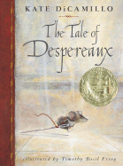

Elliott, David. The Transmogrification of Roscoe Wizzle. Cambridge, Massachusetts: Candlewick Press, 2001. Grades 3-4.

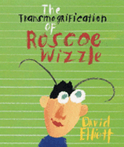 | Poor Roscoe Wizzle. His parents only ever make him mashed potatoes or tuna surprise for dinner…until the new Gussy’s fast food restaurant opens right down the street from Roscoe’s house. Suddenly, Roscoe is eating fast food meals (Jungle Drums) every night of the week! For most kids, a diet of only fast food burgers is unhealthy and unwise. But the consequence for Roscoe is much, much worse. What do you get when you mix a boy who eats too many burgers with burgers made out of….(gasp) bugs!? It can’t be good!

Gutman, Dan. The Million Dollar Strike. New York: Hyperion Books for Children, 2004. Grades 4-6.

Mrs. Felice asks her language arts class, “What are you passionate about?” Even though the whole class laughs (its hard for children to take love seriously) Ouchy answers “bowling”. Ouchy, the main character of The Million Dollar Strike, is always bowling. But when he meets Mr. Zamboni, the mysterious owner of Bowl-a-Rama, Ouchy’s real problems begin. The town wants to condemn Bowl-a-Rama because of how ugly and rundown it looks, while a crazy clown named Pinhead continually tries to destroy the bowling alley Ouchy loves. | 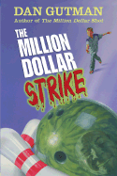

Hahn, Mary Downing. Witch Catcher. New York: Clarion Books, 2006. Grades 5-6.

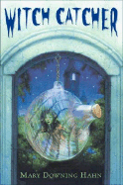 | Jen and her father have inherited an old West Virginian castle from an ancient relative. Jen’s father, during his visits to the castle to prepare for their move, has been meeting and dating Moura, a strange, beautiful woman who has a suspicious interest in the castle’s antiques especially a glowing globe rumoured to trap witches and fairies. When Jen meets Moura, she knows that the woman is not to be trusted. Over the course of the story, Jen’s suspicions grow as Moura acts less like a woman and more like a witch!

Kinney, Jeff. Diary of a Wimpy Kid. New York: Amulet Books, 2007.

“First of all, let me get something straight: This is a JOURNAL, not a diary.” And thus begins Greg Heffley’s account of his miserable time as a kid in middle school. Greg has an older brother, Rodrick, who treats him horribly, playing tricks on him and refusing him any help with bullies. Greg has a younger brother, Manny, who can do no wrong. Funny thing is, he can do wrong, but Greg always gets blamed for it. And then there is Rowley, Greg’s (best?) friend. An immature, dorky, loser of a kid who Greg just can’t seem to shake. Read Greg’s “journal” and learn what it truly is to survive as a wimpy kid. | 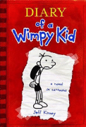

Konigsburg, E.L. From the Mixed-Up Files of Mrs. Basil E. Frankweiler. New York: Simon and Schuster Children’s Publishing Division, 1967. Grades 5-6.

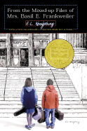 | Claudia is bored with living the same routine everyday; she wants an adventure. So, she decides to run away, taking her brother Jamie along for the adventure (he has quite a bit of money saved). They travel on bus and train to New York City and end their journey at the Metropolitan Museum of Art. Deciding to sleep in the museum, they hide from the guards in the bathroom. And so, their adventure begins. A mysterious angel statue arrives at the museum, fascinating Claudia and pulling the brother-sister duo into a mystery. Did Michaelangelo sculpt the angel? And, who is the strange lady with the file cabinet?

Korman, Gordon. Island Trilogy: Special Edition. New York: Scholastic Inc., 2005. Grades 5-6.

Luke was caught with a gun in his middle school locker. The judge, instead of sentencing him to a juvenile detention facility, allows Luke the option of attending Charting a New Course (CNC), a juvenile month-long boat trip in the Pacific Ocean designed to reform troubled children and teenagers. Unfortunately for Luke (and his fellow shipmates), events go terribly wrong and they instead have to survive a ship sinking, intense hunger and thirst, an island of bugs, pests, and wild animals, and murderous smugglers. This group of three short novels is a suspenseful and fast-paced read.

Lowry, Lois. Number the Stars. New York: Houghton-Mifflin Company, 1989. Grades 4-6.

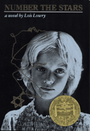 | Two best friends live in Denmark during World War II. Once of the girls, Ellen Rosen, is Jewish. Her best friend Annemarie does not care that Ellen is Jewish, but the Nazi soldiers in town do. One day the soldiers close Ellen’s parents’ button shop for good and the Rosens are forced into hiding. Annemarie’s family takes Ellen in and keeps her safe. In order to reunite her with her family so that they may all travel safely over to Sweden, Annemarie and her mother take Ellen to Uncle Henrik’s house, where the two girls begin the most dangerous and frightening adventure of their lives.

Marsden, Carolyn. Silk Umbrellas. Boston: Candlewick Press, 2004. Grades 4-6.

A story of two sisters from Thailand with different outlooks of life. Ting has been sent by their mother to work at a radio factory to bring in more money for their poor family. Noi, still in school, hopes that her mother does not also send her to the factory, a place she views as cold and hard. Instead, Noi wishes to paint beautiful, complicated designs on silk umbrellas to sell to tourists at the market. It is through her artistic gift and appreciation of colors, that Noi hopes to contribute money to her family. | 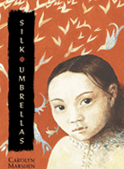

Mazer, Harry. The Wild Kid. New York: Simon and Schuster Books for Young Readers, 1998.

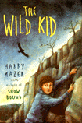 | Sammie is a child with Down’s Syndrome who is, one day, punished by his mother for saying a bad word. He is sent outside and told not to come back in before apologizing. Instead, Sammie rides off on his bike to a store to buy a candy bar. The bike is stolen, Sammie chases after it for many many miles (running, catching a ride on a truck bed, falling down ravines), until he ends up deep in the forrest, barely surviving. There, Sammie meets Kevin, the wild kid, and their adventure and friendship begin.

Selznick, Brian. The Inventions of Hugo Cabret. New York: Scholastic Press, 2007. Grades 3-6.

Waugh, Sylvia. Space Race. New York: Dell Yearling, 2000. Grades 4-6.

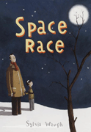 | If anyone were to look at Peter and Thomas Derwent, he would see a happy father and son living together in a small British village. However, appearances are not what they seem and noone in their village Belthorp (or on Earth, for that matter) knows that Peter and Thomas are actually Vateeling and Tonatheen from the planet Ormingat, spying on earthlings. Preparing to leave Earth for Ormingat, however, is postponed because of an accident. Suddenly young Thomas/Tonatheen must find the courage and intelligence to survive loss.

Woodsen, Jacqueline. Locomotion. New York: Scholastic Inc., 2003. Grades 3-6.

In Locomotion, a young boy must cope with the loss of parents killed in a tragic house fire. Lonnie Motion is sent to live in a foster home, under the supervision of Miss Edna. His sister Lili is also placed in a foster home, though the two of them do not see one another often. Lonnie, through his frustrations and sadness, begins to write poetry. He tells his entire story through poetic verse. The reader can recognize his sadness and, later, his hopefulness that comes about because of the love of Miss Edna and Lili. | 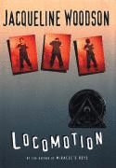

Flor Ada, Alma. I Love Saturdays y domingos. Illustrated by Elivia Savadier. New York: Atheneum Books for Young Readers, 2002. Grades preK-2.

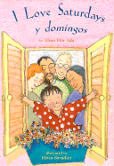 | The child in this book is lucky; she has two sets of grandparents who love her! Her father’s parents spend time with her every Saturday. Her grandmother shares her collection of owl figures and her grandfather tells stories of his European family who came to America. On domingos (Sundays), she spends time with her Abuelo and Abuela, her mother’s parents from Mexico. They take her to el circo (the circus) and serve her huevos rancheros (a special plate of eggs). She loves learning about all of her grandparents’ cultures.

Johnson, Dinah. Quinnie Blue. Illustrated by James Ransome. New York: Henry Holt and Company, 2006. Grades 1-3.

The African-American community comes alive in this story about a girl and the grandmother for whom she is named. Hattie Lottie Annie Quinnie Blue, shortened to Quinnie Blue, asks her grandmother questions about her childhood and whether she spent much of her time doing the things that Quinnie Blue loves doing: eating at the crab crack, playing handgames with friends, and walking barefoot outside. Both granddaughter and grandmother love their name, their “sassy womanchild song.” | 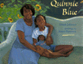

Mobin-Uddin, Asma. My Name is Bilal. Illustrated by Barbar Kiwak. Honesdale, Pennyslvania, Boyds Mills Press, Inc., 2005. Grades 2-5.

Bilal and his sister Ayesha have moved from Chicago into a suburban neighborhood where there are not many Muslim children. When some bullies pull off Ayesha’s headscarf, Bilal is afraid and does not stand up for her. In class, he claims his name is Bill, not Bilal. But his teacher Mr, Ali lends him a book about Bilal Ibn Rabah, a Muslim during the time of the prophet Muhammad, fourteen hundred years ago. After reading the book and learning more about his heritage, Bilal stands up to the bullies the next day and embraces his Muslim faith.

Mochizuki, Ken. Baseball Saved Us. Illustrated by Dom Lee. New York: Lee & Low Books, Inc., 1993. Grades K-4.

During World War II, Americans were afraid of the Japanese who lived in the United States. This was because the US was at war with Japan. They moved all of the Japanese-Americans into internment camps. In one Idaho camp, a father decides that everyone needs to play baseball to fight their boredom. The people in the camp build a stadium and play games, both young and old. The youngest of the family, Shorty, learns that he needs confidence to hit the baseball over the camp fence. | 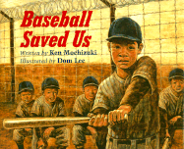

Say, Allen. Grandfather’s Journey. Boston: Houghton Mifflin Company, 1993. Grades 2-4.

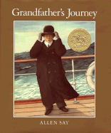 | The narrator in this story describes his grandfather and the love that he had for two countries: America and Japan. When he was in one country, he always longed for the beauty and the majesty of the other country. When he was in America he visited large canyons, cities, farmfields, and mountains. When he was in Japan he enjoyed the company of his friends and the “mountains and rivers of his childhood.” This love for two countries is passed down to his grandson, who loves the same two countries his grandfather loved.

Soto, Gary. Chato and the Party Animals. Illustrated by Susan Guevara. New York: G. P. Putnam’s Sons, 2000. Grades preK-3.

Pobrecito (Poor thing)! Novio Boy does not know when his birthday is because he came from the pound. He doesn’t even remember his mami. Luckily, he has Chato for a friend. Chato is the coolest cat around and he knows how to throw a good pachanga. He decides the very next day will be Novio Boy’s new birthday. But after Chato buys all of the party supplies, the cake, and the food, he and his friends canmot find Novio Boy anywhere. Will they find him in time to celebrate his new birthday? Read and find out! | 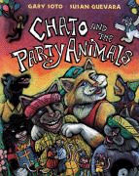

Bertrand, Lynne. Granite Baby. Illustrated by Kevin Hawkes. New York: Farrar, Straus and Giroux, 2005. Grades K-2.

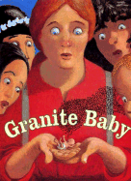 | Five larger-than-life sisters have five big talents. But when Beryl, the sister who is an amazing stonecutter, carves a small baby out of granite, suddenly their talents aren’t as handy as they had been before the arrival of the baby. The baby, named Lil’ Fella, won’t stop wailing and fussing. And despite their collective efforts, the five sisters are helplessly unable to quiet him down. Luckily, with the help of a young, farm-bred girl named Nellie, the sisters learn that taking care of a baby requires a special kind of talent.

dePaola, Tomie. Strega Nona. New York: Aladdin Paperbacks, 1975. Grades preK-3.

One eccentric old woman, one silly young man and a town full of spaghetti noodles. Enter Calebria, the magical world of Strega Nona where she cures headaches and warts, helps girls get husbands, and fills her empty pot with spaghetti using a magic spell. Big Anthony, Strega Nona’s somewhat childish servant, wants to fill the empty pot with spaghetti himself to show off to the Calebrian townspeople. The result is a crazy crisis that only the good-natured witch Strega Nona can solve. | 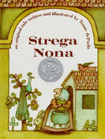

Harper, Wilhelmina. The Gunniwolf. Illustrated by William Wiesner. New York: The Trumpet Club, 1967. Grades K-2.

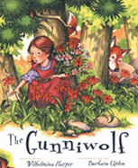 | “Little Girl, why for you move?” A young girl lives with her mother and the edge of a dangerous forest. Her mother warns her of the jungle and the dangerous Gunniwolf who lives within. However, as her mother travels to the market one day, the young girl spies beautiful red, white, and orange flowers at the edge of the forest. As he makes her way further and further in the jungle, picking flowers and singing a childlike tune, the little soon finds that she should have listened to her mother. The Gunniwolf finds her!

Hughes, Shirley. Ella’s Big Chance: A Jazz-Age Cinderella. New York: Simon and Schuster Books for Young Readers, 2003. Grades 1-3.

Winner of the 2004 Kate Greenaway Medal in Great Britain, Ella’s Big Chance puts a whole new historical spin on the original story. Yes, Ella is still oppressed by her evil stepmother. She is still a nobody when compared with her two, thin, beautiful stepsisters. She has a fairy godmother who clothes her in the ultimate jazz-age dress for the ball. But when the prince slips the small glass shoe onto her foot, Ella makes a choice the original Cinderella doesn’t make, all because her love story danced into a different direction. | 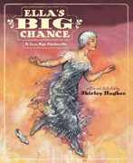

Hurston, Zora Neale. Lies and Other Tall Tales. Illustrated by Christopher Myers. New York: HarperCollins Publishers, 2005. Grades 5-6.

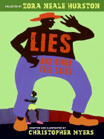 | Her stories aren’t long. There is not much plot or conflict to her character’s lives. Yet, Zora Neale Hurston provides the reader with some pretty fine jokes and laughable situations that come out of her trip “down south to talk to the prefiessional liars she growed up with.” In this colorfully illustrated tall tales collection, there are some pretty ridiculous stories. One is about the man who was so tall he stretched from hell all the way up to heaven. Another one details how a woman who was small enough to dodge raindrops.

McDermott, Gerald. Anansi the Spider: a Tale from the Ashanti. New York: Henry Holt and Company, 1972. Grades PreK-2.

Set in the Ashanti culture of Ghana, this story tells the tale of Anansi the Spider, a tricky figure who, with the help of his six spider sons, is able to avoid death and destruction again and again. The geometrical illustrations bring the spiders alive, especially because each of Anansi’s six sons have a talent: one can see trouble far away, another builds roads, the third can drink much water, the fourth is able to skin animals, the fifth can throw stones, and the sixth is very soft. Their geometrically-shaped bodies each reflect their talents. | 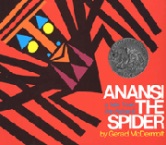

San Souci, Robert D. Cendrillon: A Caribbean Cinderella. Illustrated by Brian Pinkney. New York: Sunib abd Schuster Books for Young Readers, 1998. Grades 1-3.

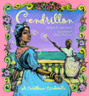 | Have you ever heard the story of Cinderella told from the perspective of her fairy godmother? No? Well, in Robert San Souci’s adaptation, set in the Creole culture of the Caribbean, Cendrillon and her washer-woman godmother are able to overcome her difficulties with her stepmother and half-sister through a magic wand made of magonany wood. The story does not differ much from the original Cinderella tale, but the drawings and french terms set the story apart from the original by emphasizing the characters’ Caribbean culture.

Steptoe, John. Mufaro’s Beautiful Daughters: An African Tale. New York: Lothrop, Lee and Shepard Books, 1987. Grades 2-3.

A folktale about two sisters who live with their father, Mufaro, in an African village many centuries ago. Although both sisters are stunning, Nyasha is kind and loving towards every person and animal, while Manyara is cruel to her sister, selfish, and vain. The folktale unfolds as Mufaro wishes to present his two daughters to the king who seeks to take a bride from the most beautiful daughters in the land. After Manyara and Nyasha travel separate magical journies to the royal city, the Great King chooses his wife. | 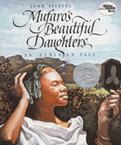

Wisniewski, David. Golem. New York: Clarion Books, 1996. Grades 4-5.

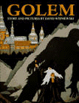 | In the 1500s, many Christians in Europe hate Jews. This hatred is unmistakable in Prague, where the Christians make the Jews live in ghettos. The citizens of Prague constantly threaten and terrorize the Jews, so Rabbi Loew, the Jewish leader, creates a man from clay to protect his people from the violence of the Jews’ enemies. Golem, the clay man, protects his Jewish friends as the citizens of Prague hear of his creation and seek to break down the ghetto’s walls to attack all of the Jews and Golem.

Young, Ed. Lon Po Po: A Red-Riding Hood Story from China. New York: Philomel Books, 1989. Grades 2-4.

Three sisters live in Northern China with their mother. Nearby, an old, clever wolf lives and waits for the perfect opportunity to catch the three girls without their mother. His time comes when she leaves to visit their grandmather (Po Po). The wolf waits until the evening and then knocks on the door, pretending to be Po Po. The remainder of the book follows the oldest daughter Shang’s realization of the wolf’s identity and her ensuing tricks to save her and her sisters from his hungry presence. | 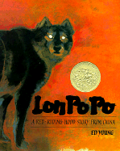

Clements, Andrew. A Million Dots. Illustrated by Mike Reed. New York: Simon and Schuster Books for Young Readers, 2006.

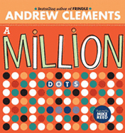 | Did you know that it would take 464,000 cartons (school-lunch size) of chocolate milk to fill a 20 by 40 foot swimming pool? Were you aware that to eat 675,000 Hershey’s bars, you would have to eat one bar every two minutes for more than 234 days? These and many other fun number facts can be found in Andrew Clements’s book A Million Dots. Along with a fun number fact per page, Clements uses his book as a tool to teach children about perspective. By the end of his 43-page book, Clements has drawn one million dots!

Cobb, Vicki. I Fall Down. Illustrated by Julia Gorton. New York: HarperCollins Publishers, 2004. Grades PreK-2.

An excellent instructional book to help children understand the concept of gravity, What happens when you trip, when you drop a bar of soap, or when you try to juggle? Everything and everybody fall down. The element that makes this book excellent for young children is that it explains the concept of gravity using connectable examples and suggested experiments for adults and children to complete together. | 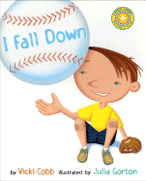

Harris, Robie H. It’s Not the Stork! A Book About Girls, Boys, Babies, Bodies, Families, and Friends. Illustrated by Michael Emberley. Cambridge, Massachusetts: Canlewick Press, 2006. Grades K-4.

A good book for a parent or adult to share with a child. Robie Harris does an excellent job explaining the similarities and differences between girls and boys and of explaining how babies are made, born, and grow. The book includes a number of helpful illustrations and is narrated by a bird and a bee, just as surprised and curious as any child will be about these natural but somewhat confusing subjects.

Jenkins, Steve. Actual Size. Boston: Houghton Mifflin Company, 2004. Grades PreK-6.

There is a particular frog that lives in Africa. When it stretches out its legs, it is three feet long. Three feet! There is an insect called the the giant walking stick; it is almost two feet long. Two feet! Steve Jenkins’s larger-(and smaller-)than-life book about the actual sizes of animals is educational and engaging for the younger reader. Not only are there suprising facts and realistic images to help children understand animal size, but Actual Size also teaches about perspective and appreciating animals and insects. | 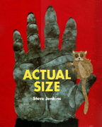

Kramer, Stephen. Hidden Worlds: Looking Through a Scientist’s Microscope. Photography by Dennis Kunkel. Boston: Houghton Mifflin Company, 2001.

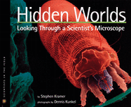 | What makes this book such an excellent supporting text is its photography. Almost every page has at least one microscope photograph of an insect, up-close, colorful, and (sometimes) gruesome. The excellent aspect of these photographs is how detailed they are. Students will be able to identify body parts of insects because the miscroscope photographs are so clear and close that every detail is recognizable.

Morrison, Gordon. A Drop of Water. Boston: Houghton Mifflin Company, 2006. Grades K-2.

A story about the journey of water. If water falls from the sky as raindrops, where does the water come from? And where does it go? Morrison’s skillfully illustrated children’s book is about the quest water makes from dripping off of mountain trees, down the mountain streams and lakes, and into marshes and farmland ponds and dams, ending with a child playing in its puddle. Through the progression of the water source, many different species of wildlife (plant and animal) benefit from the refreshing and life-giving water. | 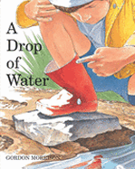

Oppenheim, Joanne. Have You Seen Bugs? Illustrated by Ron Broda. New York: Scholastic Press, 1996. K-2.

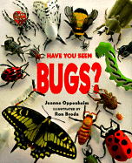 | Written in poetic form, this book addresses all of the different characteristics of bugs and their habitats. How or what do they eat? Where do they live? Why are so many of them different? This book answers simple questions about bugs and their usefulness to the Earth. It also provides colorful and accurate illustrations of the different types of bugs and then explanations of each one in the back of the book.

Romanek, Trudee. Squirt! The Most Interesting Book You’ll Ever Read About Blood. Illustrated by Rose Cowles. Toronto: Kids Can Press, 2006. Grades 2-5.

Did you know that when a bruise begins as red, blood cells have leaked out of a broken blood vessel? And, did you know that when that bruise is changing colors, the blood cells are dying? These facts and numerous other fascinating pieces of information about blood can be found in Trudee Romanek’s scientific book about the icky liquid that keeps us alive. Included within are recipes where a reader can use cooking supplies to simulate blood flow and an explanation of the injuries that are caused or healed by blood. | 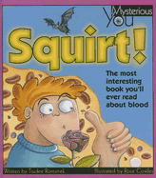

Scholastic Atlas of Weather. Edited by Martine Podesto. Montreal: Scholastic Reference, 2004. Grades 2-6.

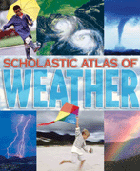 | This atlas of weather is a valuable educational tool for any child. It provides brief, general information about the Earth’s weather, the different storms and variants, and temperature facts. However, accompanying these brief explanations (one per page) are a number of a smaller “Did you know…?” facts that add interest and connectability. A great reference material for a project or for pleasure, the Atlas of Weather shows the reader what causes hail storms, the location of the hottest place on Earth, or what happens in the eye of a hurricane.

Simon, Seymour. Animals Nobody Loves. New York: SeaStar Books, 2001. Grades 2-5.

Eech! It’s a commonly known fact that there are some animals in the world that noone likes. They’re ugly, they’re dangerous, they’re annoying. But if a person were to stop and think about these animals (grizzly bears, rats, man-of-wars), he might realize that these animals, despite how distasteful they are, live to survive through any means possible. Seymour Simon realizes this and through his simple descriptions and clear, entrancing photographs, the reader learns about these hated animals and why they are Earth’s children too. | 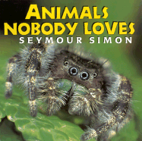

Burleigh, Robert. Toulouse-Lautrec: The Moulin Rouge and the City of Light. New York: Harry N. Abrams, Inc., 2005. Grades 4-6.

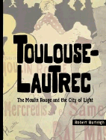 | A unique combination of biography, paintings, and photographs celebrating one of France’s artists. Henri de Toulous-Lautrec, a French nobleman, was a man crippled early in life. Because of a bone-weakening disease and two broken legs, he grew to be less than five feet tall. This physical tragedy, however, did not prevent him from making an artistic impression on the French upper-class. Associated with cabarets, paintings celebrating dancers and the opulant world of Paris, Lautrec lives on today as one of France’s premier painters.

dePaola, Tomie. 26 Fairmount Avenue. New York: G. P. Putnam’s Sons, 1999. Grades 1-3.

Tomie dePaola, the children’s book illustrator and author, tells the story of his life at five in this enchanting, illustrated chapter book. Tomie’s family had lived in the same, small apartment for a long time. In 1940, he, his parents, and his brother moved into the house where Tomie was to live the remainder of his childhood and teenage years. Read Tomie’s story and experience his five-year-old perspective as he sees Snow White in the movie theater, lives through a hurricane, and helps his parents and brother make 26 Fairmount Avenue a home. | 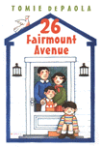

Munoz Ryan, Pam. When Marian Sang. Illustrated by Brian Selznick. New York: Scholastic Press, 2002.

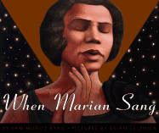 | Pam Ryan and Brian Selznick, looking for a new project involving Eleanor Roosevelt, decided to combine forces and write and illustrate a children’s biography about Marian Anderson, an African-American woman alive during the bitter prejudice in American during the first half of the 21st century. What came out of this project is a moving and beautiful tribute to an accomplished singer and person. What Marian endured helped to make her strong in faith and helped her to succeed where no other black woman in American had ever succeeded.

Pinkney, Andrea Davis. Duke Ellington: The Piano Prince and His Orchestra. Illustrated by Brian Pinkney. New York: Hyperion Books for Children, 1998. Grades 1-3.

Written in a smooth, jazz tone, this biography of the king of jazz music is melodic and rhythmic; a must-read for any cool-cat kid. Revealing the story of Duke Ellington’s life, from his early love of the piano to his historical jazz concert at Carnegie Hall in 1943, Andrea and Brian Pinkney combine forces with jiving language and colorful illustrations and bring Duke Ellington’s life and personality alive. This story of a man who defeated all odds and rose to historical fame is a pleasurable and cool read.

Ringgold, Faith. If a Bus Could Talk: The Story of Rosa Parks. New York: Simon and Schuster Books for Young Readers, 1999.

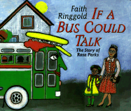 | This strong narrative story of Rosa Parks and her role in the Civil Rights Movement is made more delightful and readable by the fact that it is narrated by a bus! Yes, that’s right. The very same bus that was giving Rosa Parks a ride to work when she refused to give up her seat to a white man. The biography also gives us accounts of her young life and the family members that instilled in her feelings of pride and worth. It also describes her friendship with Dr. Martin Luther King and her experiences as a peaceful protestor.

Rubin, Susan Goldman. The Cat With the Yellow Star: Coming of Age in Terezin. Dialogue and Illustration Contributions by Ela Weissberger. New York: Holiday House, 2006.

Ela Stein was an twelve-year-old Czech Jewish girl forced into the Terezin ghetto in 1942. In the ghetto, she lived in an all-girls room for health and safety. There, she met many friends and mentors who helped her keep creativity and culture alive through drawing, singing, and acting. The most important event of her life in the ghetto was her participation in Brundibár, a children’s opera. Playing the part of the cat, Ela was able to keep hope and love alive despite the humiliating and abusive treatment she experienced during the Holocaust.

Sis, Peter. Growing Up Behind the Iron Curtain. New York: Farrar, Straus and Giroux, 2007. Grade 6.

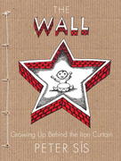 | A young boy from Czechoslovakia, a boy who loves drawing and loves rock ‘n roll music, grows up during a time of much hate and oppression. Follow this boy’s story through graphic novel-esque drawings and informational timelines that document the Soviet oppression in Czechoslovakia. Pay special attention to the journey this boy takes as he learns to live and love despite the hatred that surrounds him.

Warhola, James. Uncle Andy’s: A Faabbbulous Visit With Andy Warhol. New York: G. P. Putnam’s Sons, 2003.

Jamie Warhola the artist nephew of the famous pop artist Andy Warhol fills his pages with hilarious accounts of his childhood memories of Uncle Andy. The book’s paintings and the stories both serve to show the reader how odd and artistic Andy Warhol really was, but also how creative and popular his art was. The story centers around Jamie and his family visiting the big, bustling city of New York to visit Uncle Andy, playing among his many art forms and helping him to finish his many pop art projects. | 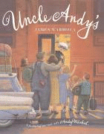

Hesse, Karen. The Cats in Krasinski Square. Illustrated by Wendy Watson. New York: Scholastic Press, 2004. Grades 1-3.

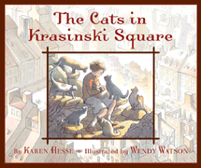 | Warsaw is living in fear because of Hitler and his evil Gestapo (German State Police). The Jews of the city have been sectioned off into the dirty ghetto. The young narrator and her sister, Mira, are living on the outside of the ghetto walls, smuggling food into their friends. But, the gestapo (and their hungry dogs) learn about the smuggling and search the trains for hidden bread and sugar. Luckily, Warsaw has been overrun with stray cats. What better way to turn the hungry dogs’ attention away from the smugglers then to use the quick, wily cats?

Polacco, Patricia. The Butterfly. New York: Philomel Books, 2000. Grades 1-3.

How should Monique react to a ghost girl showing in up in her room one night? Her mother, Marcel, tells her to forget the ghost girl, not to mention her to anyone. However, if this girl and her mother are living in a French village during World War II and Nazi rule, nothing (not even ghost girls) can be forgotten. The Butterfly tells a story of bravery and courage as Monique learns that her mother is hiding Jewish fugitives in their house, helping to save them from the Nazi soldiers. | 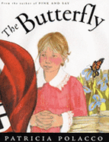

Schlitz, Laura Amy. Good Masters! Sweet Ladies! Voices from a Medieval Village. Illustrated by Robert Byrd. Cambridge, Massachusetts: Candlewick Press, 2007. Grades 4-6.

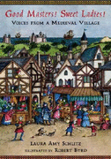 | Laura Schlitz provides older children with 23 stories of children living in a medieval village. Each child has a role in the village and a story to tell. Schlitz, a media center specialist, wrote this book to provide her students with acting roles for a medieval presentation. The story includes some of the follwing roles: Pask the runaway who is trying to live out his year in the village to gain his freedom; Mogg the villein’s daughter who is happy her violent father has died; and Edgar the falconer’s son who has stolen a sparrowhawk to set it free.

Tanaka, Shelley. Mummies: The Newest, Coolest, and Creepiest from Around the World. Archaeological Consultation by Paul Bahn. New York: Harry N. Abrams, Inc., 2005. Grades 4-6.

Mummies are pretty cool. They are creepy and ugly and rotting. But, did you know that many mummies were alive thousands of years ago? And also, that some of the mummies found today were preserved by accident? Up in Alaska, some mountain climbers found a headless mummy who had frozen to death. In Egypt, a donkey fell into a hole that ended up housing over 10,000 preserved mummies. And in the walls of some old british homes, people have found mummified cats! Read Shelley Tanaka’s fascinating book and learn the truth behind mummies and their stories! | 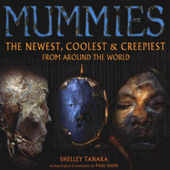

Aylesworth, Jim. The Burger and the Hotdog. Illustrated by Stephen Gammell. New York: Atheneum Books for Young Readers, 2001. Grades 1-3.

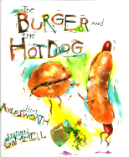 | Ever wonder whether hotdogs and hamburgers hate one another? Or whether sweet and sour pickles are friends? Aylesworth, in his book of poems, allows his readers to step inside the world of food and find what truly makes a brownie lazy or a sticky bun grumpy. His simple rhymes and easy rhythm, along with the crazy, colorful, jagged-lined illustrations of Stephen Gammell, delight any reader. Watch out! The last page invites the reader to bring his/her favorite food alive with a silly poem, just like Aylesworth’s.

Dunbar, Paul Laurence. Jump Back Honey: The Poems of Paul Laurence Dunbar. Illustrated by Ashley Bryan, Carole Cyard, Jan Spivey Gilchrist, Brian Pinkney, Jerry Pinkney, and Faith Ringgold. New York: Hyperion Books for Children, 1999. Grades 3-6.

Paul Laurence Dunbar was an African-American poet and literary genius who grew up in the wake of the Civil War. His mother was elemental in promoting education with her son and Dunbar grew up writing poetry and song lyrics in high school and into his adult life. This collection celebrates his poetry, written in both his formal English and Black dialect. Current and famed African-American children’s literature artists illustrate a number of Dunbar’s most celebrated works including, “Dawn”, “A Negro Love Song”, and “When Malindy Sings”. | 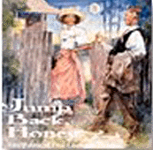

Fleischman, Paul. Joyful Noise: Poems for Two Voices. Illustrated by Eric Beddows. New York: HarperTrophy, 1988. Grades 2-6.

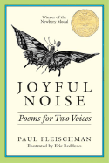 | In this Newberry Award-winning book, Fleischman presents a number of poems that center on the pleasures and woes of the insects that live around us. The beauty of this book, however, lies in the fact that all of the poems require two separate readers. All of his poems, from “Requiem” about the autumn frost and the insects it kills to “Honeybees” about the difference in lifestyle of the queen bee and the worker bee, are written with two voices, asking the readers to read at the left and right sides at the same time, simulating a musical duet.

Florian, Douglas. Omnibeasts. Orlando: Harcourt Inc., 2004. Grades PreK-2.

Where else can someone find short, simple poems about the chihuahua, the coyote, the anteater, the clam, or the vulture? Douglas Florian offers children a place to enjoy abstract paintings of many animals, some easily recognizable like “The Tiger” and some strange, unknown animals like “The Tetra”. Each colorful, hilarious painting is accompanied by a funny, short poem. Many of the poems contain a concrete element, with the words shaped or placed to represent some characteristic of the particular animal. | 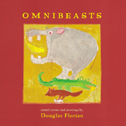

Kennedy, X. J. Exploding Gravy: Poems to Make You Laugh. Illustrated by Joy Allen. Boston: Little, Brown and Company, 2002. Grades K-3.

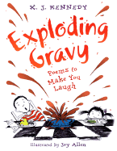 | What do children like to read about? Strange family members? Witches and ghosts? Gross food? X. J. Kennedy seems to understand the random, often weird tastes of children in his collection of poetry, Exploding Gravy. With his poems, Kennedy answers the following questions with hilarious, lyrial poetry. What does Grandpa do in the morning when he is missing hair, an eye, and a leg? Do cakes actually lay cupcakes like hens lay eggs? What happens to children who pay too much attention to the Internet and not enough to the life around them?

Merriam, Eve. Halloween ABC. Illustrated by Lane Smith. New York: Macmillan Publishing Company, 1987. Grades 1-4.

Never have repetition and tongue-twisters been so frightening. Eve Merriam provides ghoulish poems that intend to scare the reader as he or she attempts to work through the alphabet without running and hiding! Each poem employs a different rhyme scheme that matches the fright-factor of the halloween figure representing the letter. “The Owl”, representing “O”, is a long poem, but repeats the word “Who” throughout, creating an eerie, accusatory tone. However, the “Jack-o’-lantern”, represnting “J”, has a refrain and verses, ending with a statement about pumpkin pie, setting a playfully ominous tone.

O’Neill, Mary. Hailstones and Halibut Bones. Illustrated by John Wallner. New York: Doubleday, 1989. Grades 2-6.

“Turn off the light/ And colors die…And you and you and I/ Know well…each has a wonderful/ Story to tell….” This glorious collection of poems tells the stories of the simple colors that we see everyday. Mary O’Neill does not just describe the sight of colors, however. She also uses magnificent verse to explain the sound, feelings, tastes, and smells of all the colors of the rainbow. What is gold? “Like a king/ It’s like having the most/ Of everything-” How does black sound? “The sound of black is/ ‘Boom! Boom! Boom!’/ Echoing in/ An empty room.”

Frampton, Otis. Oddly Normal: Volume 1. Irving, Texas: Viper Comics, 2006. Grades 4-6.

Oddly Normal has a problem. She does not fit in at school. Part of the reason is her bright green hair. Another reason may be that her mother is an alien-witch. Whatever the reason, Oddly is not happy and she blames her freakishness on her overenthusiastic parents. So when, on her birthday, she wishes her parents “would just disappear”, her wish is granted. As her parents disappear, her crazy aunt appears and whisks her off to Fignation, the birthplace of Oddly’s mother. There she meets new friends, new enemies, and teacher who wants revenge against Oddly’s mother. | 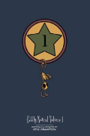

Gaiman, Neil. The Day I Swapped my Dad for two Goldfish. Illustrated by Dave McKean. China: South China Printing Company, 2004. Grades 3-5.

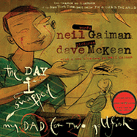 | Dads can be pretty boring when reading their newspapers. Brand-new goldfish named Sawney and Beaney, though, are a lot cooler, especially to a young boy. Neil Gaiman’s graphic story is all about what can happen when a boy is bored with his boring dad, his friends all have things that are neat and swap-able, and his sister whines about tattle-taling almost every page. Children love swapping things like electric guitars, gorilla masks, fat, white rabbits with black ears, and cool new goldfish, but all of the children in this book find out that sometimes they are happier with what is theirs.

Holm, Jennifer L. and Matthew Holm. BabyMouse Rock Star. New York: Random House, 2006. Grades 3-5.

Babymouse dreams of being a rock star. But when her flute playing forces her neighbors to throw trash through her window, she is afraid her dreams of rockstardom are lost. On top of this diappointment, Babymouse must contend with the horrrible cat bully, Felicia Furrypaws on the bus, in the hallways, and even at band practice! Will Babymouse acomplish her dream to rise to the musical top? Will she force Felicia to bow down to her flute-playing greatness? Read this hilarious black, white, and pink graphic novel and find out. | 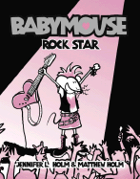

Townsend, Michael. Billy Tartle in Say Cheese! New York: Alfred A. Knopf, 2007. Grades 1-3.

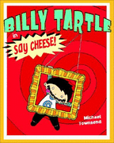 | Just like most boys, Billy Tartle does not like getting his hair cut and he does not like school pictures. They are both boring. But what if a cool haircut could make his school picture more exciting? A pink mohawk might do the trick. And if he can’t spice up his class picture with a mohawk, there are plenty of other ways. Billy teaches his classmates to never underestimate the power of a class full of multi-color lollipops!

Index by Author’s Last Name
Asch, Frank.
Mr. Maxwell’s Mouse pg 1
Avi
The True Confessions of Charlotte Doyle pg 16
Newbery Honor 1991
Horn Book Fiction Winner 1991
Aylesworth, Jim
The Burger and the Hotdog pg 37
Berenstain, Stan and Jan
The Berenstain Bears: The Bear Detectives pg 9
Bertrand, Lynne
Granite Baby pg 24
Birney, Betty G.
The World According to Humphrey pg 16
Maryland Black-Eyed Susan Winner 2005-2006
Brisson, Pat
Little Sister, Big Sister pg 9
Brandenberg, Aliki
Fossils Tell of Long Ago pg 9
Burleigh, Robert
Toulouse-Lautrec: The Moulin Rouge and the City of Light pg 32
Butler, Dori Hillestad
Trading Places with Tank Talbot pg 16
Maryland Black-Eyed Susan Winner 2006-2007
Cameron, Ann
The Stories Huey Tells pg 12
The Stories Julian Tells pg 12
Clements, Andrew
A Million Dots pg 28
Cobb, Vicki.
I Fall Down pg 28

Cronin, Doreen
Click, Clack, Moo: Cows That Type pg 1
Caldecott Honor 2001
dePaola, Tomie
26 Fairmount Avenue pg 32
Newbery Honor 2000
Strega Nona pg 24
DiCammillo, Kate
The Tale of Despereaux pg 17
Newbery Winner 2004
Dunbar, Paul Laurence
Jump Back Honey: The Poems of Paul Laurence Dunbar pg 37
Edwards, Michelle
Stinky Stern Forever pg 12
Gryphon Winner 2006
Elliott, David
The Transmogrification of Roscoe Wizzle pg 17
Falconer, Ian
Olivia pg 1
Caldecott Honor 2001
Fierstein, Harvey
The Sissy Duckling pg 2
Fleischman, Paul
Joyful Noise: Poems for Two Voices pg 37
Newbery Winner 1989
Flor Ada, Alma
I Love Saturdays y domingos pg 22
Florian, Douglas
Omnibeasts pg 38
Frampton, Otis
Oddly Normal: Volume 1 pg 40
Gaiman, Neil
The Day I Swapped my Dad for Two Goldfish pg 40
Gerstein, Mordicai
The Man Who Walked Between the Towers pg 2
Caldecott Winner 2004
Horn Book Illustration Winner 2004
Greenwald, Sheila
Rosy Cole’s Worst Ever, Best Yet Tour of New York City pg 13
Gutman, Dan
The Million Dollar Strike pg 17
Hahn, Mary Downing
Witchcatcher pg 18
Hall, Donald
Ox-Cart Man pg 2
Caldecott Winner 1980
Harper, Wilhelmina
The Gunniwolf pg 24
Harris, Robie H.
It’s Not the Stork! A Book About Girls, Boys, Babies, Bodies, Families, and
Friends pg 28
Henkes, Kevin
Kitten’s First Full Moon pg 3
Caldecott Winner 2005
Hesse, Karen
The Cats in Krasinski Square pg 35
Hest, Amy
Love You, Soldier pg 13
Holm, Jennifer L. and Matthew
Baby Mouse Rock Star pg 40
Hughes, Shirley
Ella’s Big Chance pg 25
Kate Greenaway Medal Winner 2004
Hurston, Zora Neale
Lies and Other Tall Tales pg 25

Jenkins, Steve
Actual Size pg 29
Johnson, Dinah
Quinnie Blue pg 22
Juster, Norton
The Hello, Goodbye Window pg 3
Caldecott Winner 2006
Kennedy, X.J.
Exploding Gravy: Poems to Make You Laugh pg 38
Kinney, Jeff
Diary of a Wimpy Kid pg 18
Konigsburg. E.L.
From the Mixed-Up Files of Mrs. Basil E. Frankeweiler pg 18
Korman, Gordon
Island Trilogy: Special Edition pg 19
Kramer, Stephen
Hidden Worlds: Looking Through a Scientist’s Microscope pg 29
Kvasnosky, Laura McGee
Zelda and Ivy pg 10
Look, Leonore
Ruby Lu, Brave and True pg 13
Lowry, Lois
Number the Stars pg 19
Newbery Winner 1990
Marsden, Carolyn
Silk Umbrellas pg 19
Mazer, Harry
The Wild Kid pg 20
McDermott, Gerald
Anansi the Spider: a Tale from the Ashanti pg 25
McDonald, Megan
Judy Moody pg 14
Stink: The Incredible Shrinking Kid pg 14
McLeod, Bob
Superhero ABC pg 3
McPhail, David
Edward and the Pirates pg 4
Merriam, Eve
Halloween ABC pg 38
Mobin-Uddin, Asma
My Name is Bilal pg 22
Mochizuki, Ken
Baseball Saved Us pg 23
Morris, Carla
The Boy Who was Raised by Librarians pg 4
Morrison, Gordon
A Drop of Water pg 29
Muňoz Ryan, Pam
When Marian Sang pg 32
Orbis Pictus Winner 2003
Murray, Marjorie Dennis
Don’t Wake up the Bear! pg 4
Musch, Robert
Love You Forever pg 5
O’Malley, Kevin
Once Upon a Cool Motorcycle Dude pg 5
Maryland Black-Eyed Susan Winner 2006-2007
O’Neill, Mary
Hailstones and Halibut Bones pg 39
Oppenheim, Joanne
Have You Seen Bugs? pg 30
Parish, Peggy
Come Back, Amelia Bedelia pg 10
Park, Barbara
Junie B. Jones and her Big, Fat Mouth pg 14

Pennypacker, Sara
Clementine pg 15
Pinkney, Andrea Davis
Duke Ellington: The Piano Prince and His Orchestra pg 33
Caldecott Honor 1999
Podesto, Martine (editor)
Scholastic Atlas of Weather pg 30
Polacco, Patricia
The Butterfly pg 35
Priceman, Marjorie
Hot Air: The (Mostly) True Story of the First Hot-Air Balloon Ride pg 5
Caldecott Honor 2006
Ringgold, Faith
If a Bus Could Talk: The Story of Rosa Parks pg 33
Roberts, Ken
The Thumb in the Box pg 15
Romanek, Trudee
Squirt! The Most Interesting Book You’ll Ever Read About Blood pg 30
Ross, Dev
The Birthday Ban in Munchkin Land pg 10
Rubin. Susan Goldman
The Cat With the Yellow Star: Coming of Age in Terezin pg 33
Rylant, Cynthia
Henry and Mudge: The First Book pg 11
San Souci, Robert D.
Centrillon: A Caribbean Cinderella pg 26
Say, Allen
Grandfather’s Journey pg 23
Caldecott Winner 1994
Horn Book Illustration Winner 1994
Schlitz, Laura Amy
Good Masters! Sweet Ladies! Voices from a Medieval Village pg 35
Newbery Winner 2008
Selznick, Brian
The Inventions of Hugo Cabret pg 20
Caldecott Winner 2008
Sierra, Judy
Mind Your Manners, B.B. Wolf pg 6
Silverman, Erica
Cowgirl Kate and Cocoa pg 11
Simon, Seymour
Animals Nobody Loves pg 31
Sis, Peter
Growing Up Behind the Iron Curtain pg 34
Orbis Pictus Recommended Book 2008
Soto, Gary
Chato and the Party Animals pg 23
Pura Belpré Illustration Winner 2002
Steig, William
Sylvester and the Magic Pebble pg 6
Steptoe, John
Mufaro’s Beautiful Daughters pg 26
Caldecott Honor 1988
Horn Book Illustration Winner 1988
Coretta Scott King Illustration Winner 1988
Stryer, Andrea Stenn
Kami and the Yaks pg 6
Tanaka, Shelley
Mummies: The Newest, Coolest, and Creepiest from Around the World pg 36
Townsend, Michael
Billy Tartle in Say Cheese! pg 41
Waber, Bernard
Ira Sleeps Over pg 7
Warhola, James
Uncle Andy’s: A Faabbbulous Visit With Andy Warhol pg 34
Watt, Melanie
Scaredy Squirrel pg 7
Waugh, Sylvia
Space Race pg 20
Wiesner, David
Flotsam pg 7
Caldecott Winner 2007
Willems, Mo
I am Invited to a Party! pg 11
The Pigeon Finds a Hot Dog! pg 8
Williams, Vera B
A Chair for My Mother pg 8
Caldecott Winner 1983
Horn Book Illustration Winner 1983
Wisniewski, David
Golem pg 26
Caldecott Winner 1997
Woodsen, Jacqueline
Locomotion pg 21
Yolen, Jane
Piggins pg 8
Young, Ed
Lon Po Po: A Red Riding Hood Story from China pg 27
Caldecott Winner 1990
Horn Book Illustration Winner 1990

Award Descriptions:

Caldecott: Award for most distinguished picture book for children published in the US
Coretta Scott King: Award for outstanding contribution to multicultural litereature ini
the African-American community
Gryphon: Award for outstanding fiction for which the primary audience is children in
kindergarten through fourth grades
Horn Book: Sponsored by Horn Book magazine and the Boston Globe. Award for
outstanding fiction, nonfiction, and illustration published in the US
Kate Greenaway: Award for most distinguished picture book for children published in
Great Britain
Maryland Black-Eyed Susan Award: An annual award given to books written for
various grade levels. Winners are chosen by Maryland students.
Newbery: Award for most distinguished contribution to children’s literature published in
the US
Pura Belpré: Award honoring Latino writers and illustrators for children
Orbis Pictus: Award in recognition of excellence in writing of nonfiction for children
that is published in the US

